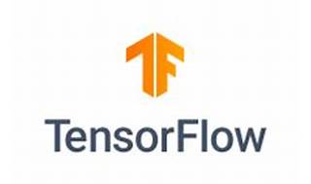

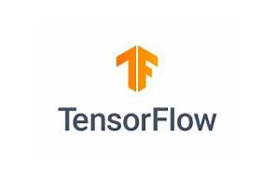

Explore

**TensorFlow** is an end-to-end platform for machine learning that simplifies the creation of ML models, allowing them to run in any environment. It provides intuitive APIs and extensive resources for learning and development.

Here are **five free reference links** where you can learn more about TensorFlow:

1. [**TensorFlow Official Documentation**](https://www.tensorflow.org/): Dive into the official documentation to explore tutorials, code samples, and guides on using TensorFlow effectively.
2. [**Introduction to TensorFlow**](https://www.tensorflow.org/learn): This resource offers a comprehensive overview of the TensorFlow ecosystem, including model construction, training, and export.
3. [**TensorFlow on Wikipedia**](https://en.wikipedia.org/wiki/TensorFlow): Learn about TensorFlow’s core features, APIs, and its role as a platform for machine learning.
4. [**TensorFlow Lite**](https://www.tensorflow.org/): Discover how to deploy machine learning models on mobile and edge devices using TensorFlow Lite.
5. [**TensorFlow.js**](https://www.tensorflow.org/): Train and run models directly in the browser using JavaScript or Node.js with TensorFlow.js.

Happy learning! 🚀🤖